Compiler Design
Theoretical Question Answer
1. What is a compiler? Explain the main purpose of a compiler in a programming language environment.
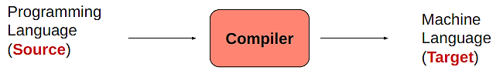
Ans: A compiler is a computer program (or set of programs) that
- Transforms source code written in a programming language
- Is a translator program

The main purpose of a compiler in a programming language environment.
• To design a translator
• Influences on programming language design
• Influences on computer design
• Compiling techniques are useful for software development
─ Parsing techniques are often used
─ Learn practical data structures and algorithms
─ Basis for many tools such as text formatters, structure editors, design verification tools,…
Source Code → Compiler → Object Code / Machine Code → Execution

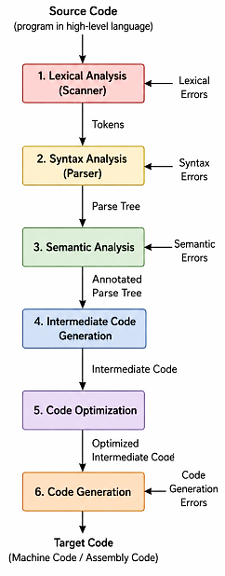
2. Differentiate between a compiler and an interpreter.
Compiler | Interpreter
Translates the whole program at once. | Translates one line at a time.
Generates an executable file. | Does not create an executable file.
Finds errors after compiling the whole program. | Finds errors line by line immediately.
Program execution is faster after compilation. | Program execution is slower because translation happens during running.
Example: C Programming Language, C++ | Example: Python, JavaScript

3. What are the various phases of a compiler? Briefly explain the function of each phase with a proper figure.

Explain the each function:
i. Lexical analysis: Experience with Regular Expressions and will be important when you deal with
- big text files;
- automating routine text processing tasks.
ii. Syntax Analysis: Parsing is important in
- Text and language processing tasks; if you're trying to interpret tweets or sentences, etc.
iii. Semantic Analysis:
- At this stage, actually start to understand the programming languages that use even in our day to day life.
- Understanding various constraints related to assignment, allocation
iv. Intermediate Code Generation:
- Generates middle level code according to the semantics.
- You will learn different platform independent codes
v. Code Optimization:
- introduced to various Optimization techniques in code generation.
- also be more critical of the code write for other works.
vi. Code Generation:
- learn to generate the Machine Code.
- This forces to learn Assembly Language;
- an overview of applying basic Computer Architecture concepts.
4. What is lexical analysis? What is the role of a lexical analyzer in a compiler?
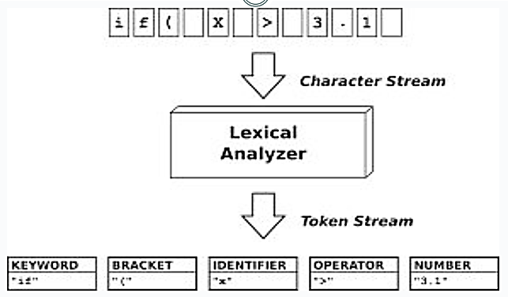
Lexical analysis is the first step in a compiler where the source code is broken into small meaningful parts called tokens (like words, numbers, and symbols).
The role of Lexical analyzer:
- First phase of a compiler
- Main task
- To read the input characters
- To produce a sequence of tokens
- An assistant of parser

5. Define the following terms with examples:
a. Token
b. Lexeme

Ans: a) Token: A token is a small meaningful unit of a program in a programming language. Types of words in source program like Keywords, operators, identifiers, constants, literal strings, punctuation symbols (such as commas, semicolons).
Example:
- Keywords: int, if, return
- Identifiers: sum, x, total
- Operators: +, -, =
- Symbols: ;, (), {}
- Numbers: 10, 25

b) Lexeme: Actual words in source program matched by pattern. It’s a valid token.
Example: int, sum, = , 10
6. What is syntax analysis (parsing)? Why is it important in the compilation process?
Syntax Analyzer creates the syntactic structure of the given source program. This syntactic structure is mostly a parse tree.
The syntax of a programming is described by a context-free grammar (CFG) or BNF (Backus-Naur Form) notation.

Why it is important:
- Checks program structure
- Finds syntax errors
- Builds parse tree
- Helps later phases

7. What is context-free grammar (CFG)? Explain the different components of a CFG with an example.
A Context-free Grammar (CFG) is utilized to describe the Syntactic Structure of a Language.

Components of CFG: A CFG is written as a 4 tuple like that G = T, N, P, S

1. Terminals(T): These are the actual symbols of the language. They cannot be broken further.
Example: id, +, -, *, /, (, )
2. Non-terminals / Variables (N/V): These are symbols that can be replaced further. They help define structure.
Example: expr, op
3. Productions(P): These are the rules used to replace variables.
Example: expr → expr op expr, expr → ( expr ), expr → - expr, expr → id, op → + | - | * | /
4. Start Symbol(S): The starting point of the grammar. Usually represented by S.
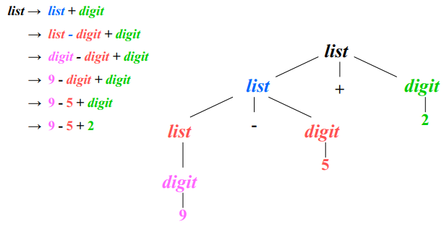
Example: expr
8. What is the purpose of a parse tree?
- Checks syntax correctness
- Shows program structure
- Helps detect syntax errors
- Helps semantic analysis
- Supports code generation
9. Define Ambiguity in CFG with proper examples.
A grammar produces more than one parse tree for a sentence is called as an ambiguous grammar. A CFG is ambiguous if one string can have more than one parse tree.

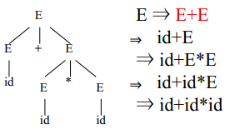
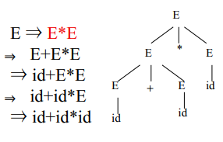
Example:
E → E + E | E – E | E * E | E / E | - E
E → ( E )
E → id

Technical Questions
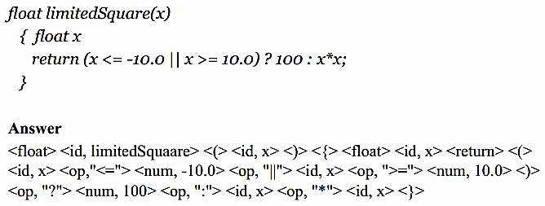
1. Given a piece of code and the CFG, divide the program into appropriate lexeme. Slide-2, Page: 27-32
i.

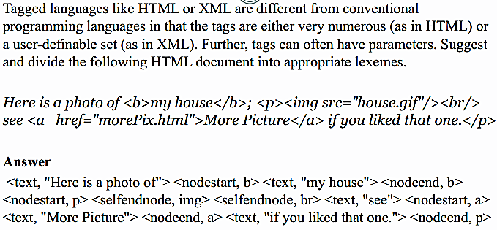
ii.

2. Write the regular expressions for matching given types of strings. Slide-2, Page: 14-26
String Matching: i. Username RegEx, ii. Password RegEx, iii. Email Address RegEx, iv. Validate Date
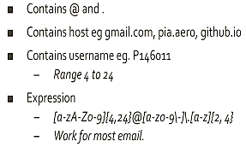
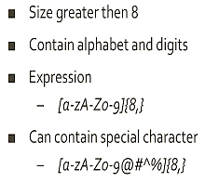
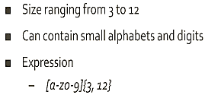
i. Username RegEx: ii. Password RegEX: iii. Email Address RegEx:

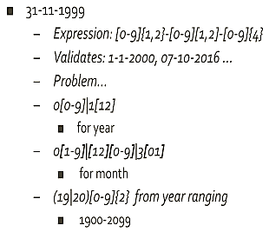
iv. Valid Date RegEx:

3. Given a CFG, check if ambiguous. Slide-3, Page: 18-24
Ambiguous: E → E + E | E – E | E * E | E / E | - E
E → ( E )
E → id
Case 1: (id + id) * id Case 2: id + (id*id)
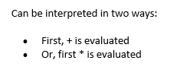
In this grammar:
- There is no precedence rule for + and *
- The same expression can be grouped in different ways
- Therefore, multiple parse trees can be formed

This CFG is Ambiguous, because for the same string.

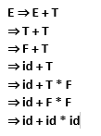
Unambiguous : E → E + T | T
T → T * F | F
F → id case : id + id * id
In this grammar:
✔ * has higher priority than +
✔ Fixed grammar rules decide structure
✔ Only one valid parse tree exists for each string

This CFG is Unambiguous because every valid string has only one unique parse tree and derivation.

End

Slide – 02
Page 27-32
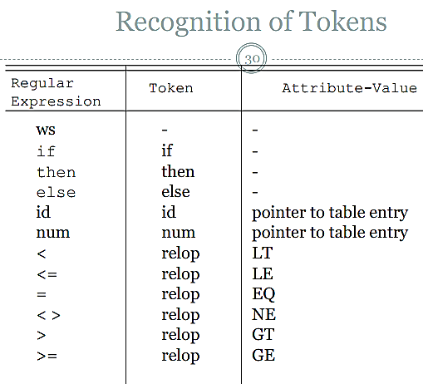
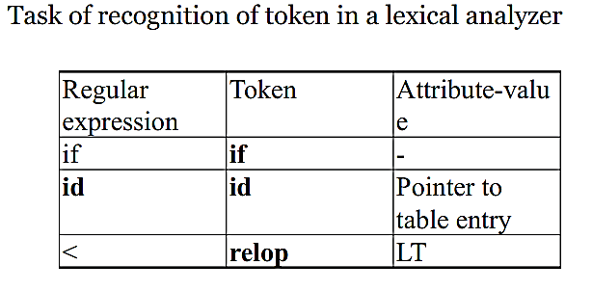
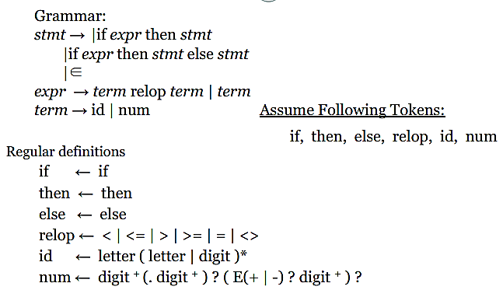

Slide – 03
Page 18-24
